Chapter 11, Solution 79.

The wattmeter reads the power supplied by the source and partly absorbed by the 40- resistor.

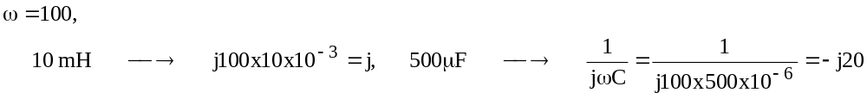

The frequency-domain circuit is shown below.

20 I_{o}

I 40 j
V₁ V₂

+1
2 I_{o}
10<0º -j20
-

At node 1,

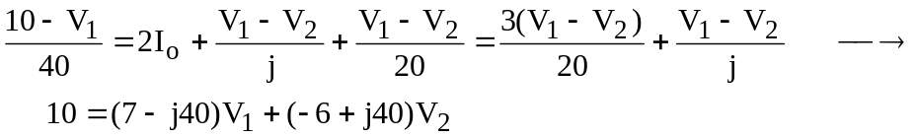 (1)

At node 2,

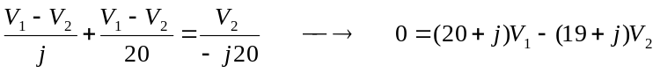 (2)

Solving (1) and (2) yields V₁ = 1.5568 –j4.1405

P = Re(S) = 50 mW.

